# YOUTUBE SPAM DETECTION: LEVERAGING ENSEMBLE ALGORITHMS FOR ROBUST FILTERING

By

**SURIYA S**

Roll No: 2231MCA0004

Register No: 67222100058

A PROJECT REPORT

Submitted to the

FACULTY OF INFORMATION AND COMMUNICATION ENGINEERING

*in partial fulfillment of the award of the degree*

*of*

**MASTER OF COMPUTER APPLICATION**



**CENTER FOR DISTANCE EDUCATION**

**ANNA UNIVERSITY**

**CHENNAI – 600 025**

APRIL, 2024

# BONAFIDE CERTIFICATE

Certified that the project report titled “**YOUTUBE SPAM DETECTION: LEVERAGING ENSEMBLE ALGORITHMS FOR ROBUST FILTERING**” is the bonafide work of **Mr. S SURIYA** who carried out the work under my supervision. Certified further that to the best of my knowledge the work reported herein does not form part of any other project report or dissertation on the basis of which a degree or award was conferred on an earlier occasion on this or any other candidate.

Signature of Student Signature of Guide

**Mr. S SURIYA Dr. P. GEETHA**

Roll No: 2231MCA0004 Associate Professor

Register No: 67222100058 Department of IST

Anna university

Chennai 600 025

# CERTIFICATE OF VIVA-VOICE EXAMINATION

This is to certify that Mr. SURIYA S (**Roll No:** 2231MCA0004**; Register No:** 67222100058) has been subjected to Viva-voice-Examination on ………………... at the study Centre **Centre for Distance Education, Anna University.**

Internal Examiner External Examiner

Name : Name :

Designation : Designation :

Address : Address :

**Coordinator Study Center**

Name :

Designation :

Address :

# ACKNOWLEDGEMENT

First and foremost, I would like to thank **Dr. P. NIRMAL KUMAR**, Professor and Additional Director, Centre for Distance Education, Anna University, Chennai for his constant motivation throughout the course.

I am most grateful to **Dr. P. GEETHA**, Associate Professor in the Department of Information Science and Technology at the College of Engineering, Guindy Campus, Anna University, Chennai for her guidance and constant supervision as well as for providing necessary information throughout the completion of this project. I also thank my review committee member **Dr. S. PRADEEP**, Assistant Professor, Centre for Distance Education, Anna University, Chennai, for his moral support.

I am also grateful to my parents, friends and colleagues for their timely support and constant words of encouragement. Last but not the least; I extend my thanks to The Almighty.

**SURIYA S**

# ABSTRACT

The ever-growing popularity of YouTube has brought with it a deluge of unwelcome guests: spam comments. These disruptive messages not only detract from user experience but also stifle genuine conversation. While YouTube employs its own filtering system, it often falls short in completely eradicating the problem.

This research proposes a novel approach to combating YouTube spam – leveraging the power of ensemble learning. The existing studies on YouTube spam detection and conduct a series of classification experiments. By harnessing the capabilities of machine learning and ensemble approaches, this research aims to develop a robust system for filtering YouTube spam comments, fostering a more positive and engaging online platform for users. Five individual machine learning algorithms are put to the test: Decision Tree, Logistic Regression, Random Forest, SVM, Extra Tree Classifier. Additionally, The potential of two ensemble models: Ensemble with Hard Voting and Ensemble with Soft Voting. These models combine the strengths of individual algorithms, aiming to achieve a superior level of spam detection accuracy.

To comprehensively evaluate these techniques, to train them on a dataset of comments from popular music videos by renowned artists.

# தலைப்புச்சுருக்கம்

YouTube இன் பிரபலமடைந்து வரும் பிரபலம், விரும்பத்தகாத விருந்தினர்களின் வெள்ளத்தைக் கொண்டு வந்துள்ளது: ஸ்பேம் கருத்துகள். இந்த சீர்குலைக்கும் செய்திகள் பயனர் அனுபவத்தை குறைப்பது மட்டுமல்லாமல் உண்மையான உரையாடலையும் முடக்குகின்றன. யூடியூப் அதன் சொந்த வடிகட்டுதல் முறையைப் பயன்படுத்தினாலும், சிக்கலை முற்றிலுமாக அகற்றுவதில் அது பெரும்பாலும் குறைகிறது.

இந்த ஆராய்ச்சி YouTube ஸ்பேமை எதிர்த்துப் போராடுவதற்கான ஒரு புதிய அணுகுமுறையை முன்மொழிகிறது - குழுமக் கற்றலின் சக்தியை மேம்படுத்துகிறது. YouTube ஸ்பேமைக் கண்டறிதல் மற்றும் தொடர் வகைப்பாடு சோதனைகளை நடத்துவது குறித்த தற்போதைய ஆய்வுகள். இயந்திர கற்றல் மற்றும் குழும அணுகுமுறைகளின் திறன்களைப் பயன்படுத்துவதன் மூலம், இந்த ஆராய்ச்சியானது YouTube ஸ்பேம் கருத்துகளை வடிகட்டுவதற்கான வலுவான அமைப்பை உருவாக்குவதை நோக்கமாகக் கொண்டுள்ளது. ஐந்து தனிப்பட்ட இயந்திர கற்றல் வழிமுறைகள் சோதனைக்கு உட்படுத்தப்படுகின்றன: முடிவு மரம், லாஜிஸ்டிக் பின்னடைவு, ரேண்டம் ஃபாரஸ்ட், SVM, கூடுதல் மர வகைப்பான். கூடுதலாக, இரண்டு குழும மாதிரிகளின் திறன்: கடின வாக்களிப்புடன் குழுமம் மற்றும் மென்மையான வாக்களிப்புடன் குழுமம். இந்த மாதிரிகள் தனிப்பட்ட அல்காரிதம்களின் பலத்தை ஒருங்கிணைத்து, ஸ்பேம் கண்டறிதல் துல்லியத்தின் உயர்ந்த நிலையை அடைவதை நோக்கமாகக் கொண்டுள்ளன.

இந்த நுட்பங்களை விரிவாக மதிப்பீடு செய்ய, புகழ்பெற்ற கலைஞர்களின் பிரபலமான இசை வீடியோக்களில் இருந்து கருத்துகளின் தரவுத்தொகுப்பில் அவர்களுக்குப் பயிற்சி அளிக்கிறோம்.

**TABLE OF CONTENT**

|  |  |  |
| --- | --- | --- |
| **CHAPTER NO** | **TITLE** | **PAGE NO** |

ABSTRACT (ENGLISH) iv

ABSTRACT (TAMIL) v

LIST OF FIGURES viii

LIST OF TABLES viii

LIST OF ABBREVIATION viii

1. INTRODUCTION 1

1.1 OBJECTIVE 1

1.2 PROBLEM STATEMENT 2

1.3 SCOPE OF PROJECT 2

1.4 ACHIEVEMENTS 3

1.5 EXISTING SYSTEM 3

1.8 COMPARISON OF EXISTING AND PROPOSED SYSTEM 4

1. SYSTEM SPECIFICATION 5

2.1 HARDWARE REQUIREMENTS 5

2.2 SOFTWARE REQUIREMENTS 5

2.3 DOMAIN KNOWLEDGE 5

1. SYSTEM DESIGN 8

3.1 SYSTEM ARCHITECUTURE 8

3.2 MODEL OVERVIEW 9

3.2.1 COMMENT EXTRACTION 10

3.2.2 PRE-TRAINED MODEL 11

3.2.3 SPAM CLASSIFICATION 12

3.2.4 CLASSIFIED COMMENTS AS OUTPUT 13

3.2.5 PDF REPORT GENERATION 13

1. IMPLEMENTATION AND RESULT DISCUSSION 14

4.1 MODULE IMPLEMENTATION 14

4.1.1 TESTING AND TRAINING 14

4.1.2 SPAM DETECTION 15

4.2 DATA SETS 16

4.3 TEST CASES AND RESULT 19

4.4 PERFORMANCE ANALYTICS 21

1. CONCLCUSION 29

5.1 FUTURE WORK 29

REFERENCES 31

**LIST OF FIGURES**

|  |  |  |
| --- | --- | --- |
| **FIGURE NO.** | **TITLE** | **PAGE NO** |
| 3.1 | Block Diagram | 8 |
| 4.1 | Spam Classification | 18 |
| 4.2 | Comments Extraction | 20 |
| 4.3 | Comments Classification | 20 |
| 4.4 | Report Generation | 20 |
| 4.5 | Classification Report for Decision Tree | 22 |
| 4.6 | Classification Report for Logistic Regression | 23 |
| 4.7 | Classification Report of Random Forest | 24 |
| 4.8 | Classification Report for SVM | 25 |
| 4.9 | Classification Report for Extra Tree Classifier | 26 |
| 4.10. | Performance Comparison After Simple Modeling | 27 |

**LIST OF TABLES**

|  |  |  |
| --- | --- | --- |
| **TABLE NO** | **TITLE** | **PAGE NO** |
| 2.1 | Existing System vs Proposed System | 5 |
| 4.1 | Sample Dataset | 18 |
| 4.2 | Test Cases | 19 |
| 4.3 | Formulas | 21 |
| 4.4 | Decision Tree Classification Report | 22 |
| 4.5 | Logistic Regression Classification Report | 23 |
| 4.6 | Random Forest Classification Report | 24 |
| 4.7 | SVM Classification Report | 25 |
| 4.8 | Extra Trees Classifier Report | 26 |
| 4.9 | Classification report for all the models | 28 |

**TABLE OF ABBREVIATION**

|  |  |  |
| --- | --- | --- |
| ABBREVIATION |  | EXPANSIONS |
| NLP | - | Natural Language Processing |
| HTML | - | Hypertext Markup Language |
| CSS | - | Cascading Style Sheets |
| CSV | - | Comma-Separated Values |
| PDF | - | Portable Document Format |
| ML | - | Machine Learning |
| AI | - | Artificial Intelligence |
| SVM | - | Support Vector Machine |

**CHAPTER 1**

# INTRODUCTION

## OBJECTIVE

In the ongoing fight against spam, ML algorithms like Random Forest and SVMs have emerged as sophisticated tools. These techniques excel at distinguishing spam from legitimate emails [3] due to several key strengths. Firstly, they can effortlessly handle massive datasets, a critical requirement considering the ever-expanding volume of email traffic. This scalability ensures the spam filter remains effective as email usage continues to grow. Secondly, these algorithms are resistant to overfitting, a common pitfall where a model memorizes the training data too well and struggles with new emails. This robustness prevents the filter from becoming outdated as spammers employ new tactics. Perhaps most importantly, these algorithms offer interpretability, the ability to explain their classifications. This transparency is essential for building trust in the system and for ongoing improvement. By strategically combining the strengths of multiple decision trees, these algorithms can uncover intricate and nuanced patterns within emails that are hallmarks of spam content. This leads to highly accurate spam filtering, protecting users from unwanted and potentially malicious emails [7]. Furthermore, the insights gleaned from these algorithms can be used to continuously refine the spam filter, ensuring it stays ahead of evolving spammer techniques.

These same principles can be applied to tackle spam comments on YouTube videos. The leveraging pre-trained ML model, similar to those used for email spam detection [3][7], to analyze comments on YouTube videos. This model will be trained on a vast dataset of labeled YouTube comments, allowing it to distinguish between genuine discussion and spam. By focusing on the YouTube ecosystem, can tailor the model to identify patterns specific to spam comments on this platform. This user-driven approach empowers viewers to analyze comments on any YouTube video and gain a clearer picture of the comment section. The project aims to reduce the prevalence of spam comments, fostering a more informative and engaging environment for the YouTube community.

## PROBLEM STATEMENT

The phenomenal growth of YouTube has unfortunately attracted a surge of malicious actors. Spam comments disrupt user experience by flooding comment sections with irrelevant promotional content, phishing attempts, and other security risks [10]. While YouTube employs a filtering system to mitigate this issue, it faces significant limitations:

* Static Rule Vulnerability: The current filter relies on pre-defined rules, making it susceptible to evolving spam tactics. As spammers employ more sophisticated techniques and obfuscate messages, the filter's effectiveness diminishes.
* Inaccurate Detection: Strict filtering rules can lead to false positives, inadvertently removing legitimate comments that contain keywords or phrases commonly associated with spam. This frustrates users attempting genuine conversation.
* Lack of Transparency: The filtering process remains opaque to users. When comments are flagged as spam, there's minimal explanation provided, hindering trust and user understanding.

These limitations highlight the critical need for a more robust and adaptable approach to tackling YouTube spam comments. This project aims to address this challenge by proposing a novel solution.

## SCOPE OF PROJECT

The “**YOUTUBE SPAM DETECTION: LEVERAGING ENSEMBLE ALGORITHMS FOR ROBUST FILTERING”** project focuses on developing a web application specifically designed to address spam comments on YouTube videos. While existing research explores spam detection across various online platforms, whereas this will be limited to the YouTube ecosystem. This focus on reducing the prevalence of spam comments and enhancing user experience within YouTube comment sections.

## ACHIEVEMENTS

**Successful Implementation**

Successfully designed and developed a web application leveraging ML algorithms to identify and filter spam comments within YouTube video comment sections. This application empowers users to analyze comment landscapes and fosters a more positive online environment for YouTube users.

**Challenges Overcome**

A key hurdle was fetching YouTube comments, which load as users scroll. We tackled this by implementing Selenium, a web automation tool. Selenium simulates user interaction, allowing the application to scroll and trigger comment loading, resulting in comprehensive comment extraction for analysis.

## EXISTING SYSTEM

While YouTube offers a built-in spam filter as a first line of defense, it has limitations. This filtering system relies on pre-defined rules and algorithms to identify and remove spam comments. However, these rules may not be exhaustive, and spammers are constantly innovating their tactics [8]. As a result, a significant number of spam comments can bypass the filter, negatively impacting user experience and hindering genuine conversation within comment sections.

Researchers have actively explored the potential of machine learning in tackling YouTube spam comments. These studies have investigated the application of various individual ML algorithms [6] , such as Decision Trees, Naive Bayes, SVMs, and Random Forests, for spam detection. Each approach has its strengths and weaknesses. For instance, Decision Trees offer clear decision-making logic but can be susceptible to overfitting the training data. Naive Bayes is efficient but may struggle with complex data patterns, such as the nuanced language used in some spam comments.

These prior studies provide valuable insights into the effectiveness of individual ML algorithms for YouTube spam detection. However, they typically evaluate the performance of algorithms on specific datasets. This approach may not adequately address the ever-evolving nature of spam tactics. Spammers continuously adapt their strategies, and a model trained on a static dataset may not be effective in identifying new forms of spam.

According to Tingmin Wu, Shigang Liu, Jun Zhang, and Yang Xiang, Spotting spam on Twitter is a major challenge in 2021 [11]. Existing methods using machine learning or blacklists reach around 80% accuracy, but struggle to adapt to new tricks spammers use. This paper proposes a new approach based on deep learning. It analyzes the language patterns of tweets to identify spam. The researchers tested their method on real tweets and found it outperforms current text-based methods.

## COMPARISON OF EXISTING AND PROPOSED SYSTEM

**Table 2.1 Existing System vs Proposed System**

|  |  |  |
| --- | --- | --- |
| Feature | Existing System (YouTube Filter) | Proposed System (Ensemble Learning) |
| Functionality | Automated spam filtering based on pre-defined rules [1] | Leverages ML for spam detection and classification |
| Strengths | Easy to implement, reduces some spam. | Potentially higher accuracy, adaptable to evolving spam |
| Weaknesses | Limited adaptability, may miss complex spam [9] | More complex to implement, requires training data |
| Overall Effectiveness | Moderate, may struggle with evolving tactics | Potentially superior spam detection, ability to learn |

**CHAPTER 2**

# SYSTEM SPECIFICATION

## HARDWARE REQUIREMENTS

The application has been developed with the system having the following requirements:

* Processor: AMD Ryzen 5 5600H with Radeon Graphics, 3301 MHz
* RAM: 8 Gb
* Hard Disk: 500 GB (SSD)

## SOFTWARE REQUIREMENTS

The application has been developed with the system having the following requirements:

* Operating System: Windows 11
* Front End: Html, CSS, JavaScript
* Scripts: Python Language (Version 3.10.8)
* Software: VS Code with Jupiter Extension

## DOMAIN KNOWLEDGE

This project delves into the realm of YouTube spam comments, requiring a multifaceted understanding of the technical and strategic aspects involved. Here's a breakdown of the crucial domain knowledge areas:

**Understanding the YouTube Spam Landscape:**

* Spammer Tactics: Familiarity with common strategies employed by spammers on YouTube, including keyword stuffing, promotional links, phishing attempts [8], and comment manipulation techniques. This knowledge is vital for effectively training the ML model to identify these malicious content patterns.
* Evolution of Spam: An awareness of how spam tactics adapt and evolve over time. Spammers constantly seek new ways to bypass detection [4]. Understanding this dynamic is essential for developing a system that can maintain its effectiveness in the long run.
* Limitations of Existing Filters: Knowing the weaknesses of current YouTube spam filters, such as their reliance on static rules and susceptibility to new spam tactics. This knowledge helps identify areas where the proposed ensemble machine learning approach can offer significant improvements.

**Machine Learning for Text Classification:**

* Text Classification Algorithms: A solid grasp of ML algorithms adept at text classification tasks, specifically those suited for spam detection. This knowledge base informs the selection of the most appropriate pre-trained model.
* Model Selection and Training: The ability to evaluate different pre-trained models based on factors like accuracy, efficiency, and suitability for the specific task of YouTube comment classification. Additionally, understanding how to fine-tune or retrain the chosen model if necessary.
* Evaluation Metrics: Knowledge of relevant metrics for assessing the performance of the ML model in spam detection. This could include metrics like precision, recall, F1-score, and accuracy.

**Web Scraping with Ethical Considerations:**

* Selenium for Comment Extraction: Proficiency in using Selenium, a web automation tool, to ethically extract comments from YouTube videos while adhering to YouTube's Terms of Service and respecting user privacy. This involves understanding best practices for responsible scraping and avoiding overloading YouTube's servers with excessive requests.
* Respecting User Privacy: Awareness of the importance of user privacy when scraping comments. This might involve anonymizing or not storing any personally identifiable information extracted from the comments.

**UI Design:**

* User-friendliness: Understanding the principles of user-friendly interface design to create an application that is easy to navigate and understand for users of varying technical backgrounds. This involves clear instructions, intuitive layouts, and informative feedback mechanisms.
* Accessibility: Awareness of accessibility guidelines to ensure the UI is usable for people with disabilities. This might involve considerations for color contrast, keyboard navigation, and screen reader compatibility.

**CHAPTER 3**

# SYSTEM DESIGN

## SYSTEM ARCHITECUTURE

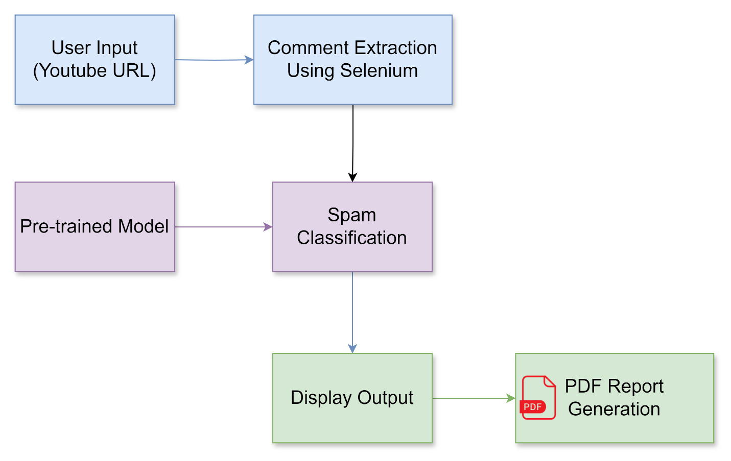

**Figure 3.1 - Block Diagram**

The above block diagram (Figure 3.1) provided represents the workflow of your web application designed to detect spam comments on YouTube videos. The arrows in the diagram depict the flow of data throughout the application. Here's the sequence:

* Users enter a YouTube video URL in the User Input section.
* This URL is passed to the Selenium Engine, which interacts with the YouTube website and extracts comments from the specified video.
* The extracted comments are then fed into the pre-trained ML Model.
* The model analyzes each comment and assigns a classification (spam or legitimate) along with an accuracy score.
* The classified comments with their labels and scores are displayed in the Output section for the user to review.

Overall, the block diagram provides a clear visual representation of how your web application leverages Selenium and a pre-trained ML model to identify and categorize spam comments within YouTube video comment sections.

## MODEL OVERVIEW

**Components:**

* User Input (URL): This block represents the starting point where users interact with the application. It allows users to enter the URL of a YouTube video they want to analyze for spam comments.
* Comment Extraction: This block represents the process of retrieving comments from the YouTube video using Selenium. It signifies the steps Selenium takes to navigate the web page, locate the comment section, and collect the comment text for each entry.
* Pre-trained Model: This block represents a pre-trained model you've chosen for spam classification. This model has already been trained on a large dataset of labeled comments (spam and legitimate) and can analyze text to predict its category.
* Spam Classification: This block depicts the core functionality of the application. The extracted comments are fed into the pre-trained model, which analyzes each comment and assigns a classification (spam or legitimate) based on its learned patterns. The model also generates an accuracy score indicating its confidence level in the prediction.
* Classified Comments as Output: This block represents the final results presented to the user. It showcases the extracted comments alongside their corresponding classifications (spam or legitimate) and the accuracy scores provided by the model.
* PDF Report Generation: This block represents the functionality where users can select comments, they believe are spam and generate a PDF report. This report would likely include details like the video information (URL, title, channel name), the flagged comments with their classifications, and timestamps of PDF generated for reference.

### COMMENT EXTRACTION

This module serves as the foundation for the comment analysis process. It leverages a powerful web automation tool called Selenium to retrieve comments from the target YouTube video. Here's a breakdown of its operation:

* User Input: This module acts as the starting point for your spam analysis. Just by providing the URL of the YouTube video, it starts to investigate. The application needs to know which video to focus on to analyze the comments within that specific section.
* URL Validation: The initial step involves the validation of the user-provided URL. Our system employs robust validation techniques to ensure the URL points to a legitimate YouTube video. This safeguards against potential errors and ensures the subsequent extraction process targets the correct content.
* Selenium Invocation: Following successful URL validation, Selenium is invoked. Selenium acts as a skilled web navigator, utilizing the validated URL to navigate to the specific YouTube video page. This ensures the extraction process focuses on the intended comments section.
* Dynamic Content Handling: Modern web pages often employ dynamic content loading techniques. Our system acknowledges this and incorporates strategies to handle such dynamic elements. This ensures that even comments loaded asynchronously after the initial page load are successfully captured by Selenium.
* Comment Section Identification: Upon reaching the video page, Selenium employs advanced element locators to precisely identify the designated comment section. These locators are designed to be adaptable and resilient to potential layout variations across different YouTube videos. This ensures consistent comment extraction regardless of the video's specific design.
* Comment Text Extraction: Once the comment section is pinpointed, Selenium meticulously extracts the text content of each individual comment within that section. This process may involve navigating through paginated comment sections if the video has a large number of comments. The extracted comments are then meticulously formatted and prepared for further analysis.
* Data Delivery: Finally, the collected comment text data is delivered as a structured dataset to the subsequent stage of the process. This dataset serves as the raw material for the machine learning engine, which will analyze each comment to identify potential spam content.

By operating efficiently behind the scenes, this module lays the groundwork for a comprehensive comment analysis experience. It ensures the retrieval of the necessary data (comments) from the target YouTube video, paving the way for a more informed and insightful user experience.

### PRE-TRAINED MODEL

This module represents the core of our comment analysis system - a pre-trained ML model. Think of it as a highly skilled analyst with a wealth of experience in identifying spam content. Here's a closer look at its functionality:

* Standing on the Shoulders of Giants: Extensive research has been conducted on YouTube spam detection. Building upon this valuable foundation, we've explored a wide range of ML algorithms, including Decision Tree, Logistic Regression, Random Forest, SVM, and Extra Tree Classifier. Additionally, we've delved into the power of ensemble models, which combine the strengths of multiple algorithms like Ensemble with Hard Voting and Ensemble with Soft Voting. Through a series of classification experiments, we've meticulously evaluated the performance of each approach.
* Choosing the Champion: Based on the experiment results, a selected pre-trained model that demonstrates exceptional accuracy in distinguishing spam comments from legitimate discussions. This model has been meticulously trained on a vast dataset of labeled comments, allowing it to recognize the subtle patterns and characteristics that define spam content.
* Expert Analysis: Once comments are extracted from the target YouTube video, they're presented to this pre-trained model. The model then analyzes each comment individually, leveraging its acquired knowledge to predict the likelihood of it being spam. This analysis process is akin to a skilled professional meticulously examining evidence to reach a conclusion.

By incorporating this powerful pre-trained model, our system strives to provide a more nuanced understanding of the comment section associated with any YouTube video you choose to analyze.

### SPAM CLASSIFICATION

This module represents the heart of the application's functionality. Extracted comments from the target YouTube video are fed into a pre-trained ML model. This model acts as a sophisticated classifier, having been meticulously trained on a vast dataset of labeled comments [2]. Through this training, the model has learned to identify subtle patterns and characteristics that distinguish spam content from legitimate discussions. As each comment is presented to the model, it undergoes a rigorous analysis process. The model leverages its acquired knowledge to predict the likelihood of the comment being spam and assigns a corresponding classification (spam or legitimate) [2]. Additionally, the model generates an accuracy score for each prediction, indicating its confidence level in the classification. This score provides valuable insight into the certainty of the model's analysis. By employing this powerful central analysis engine, the application is able to deliver a comprehensive understanding of the comment section associated with any YouTube video you choose to analyze.

### CLASSIFIED COMMENTS AS OUTPUT

This module delivers the analysis results in a user-friendly format. Extracted comments appear alongside their classifications (spam or legitimate) and corresponding accuracy scores. These scores indicate the model’s confidence in each prediction, helping you gauge the potential for false positives or negatives. This clear presentation empowers you to grasp the comment section’s content, identify potential spam, and form an informed opinion about the overall discussion.

### REPORT GENERATION

The final step provides a clear picture of the comment section. An automatically generated PDF report details the video information (URL, title, channel name), along with all extracted comments and their corresponding classifications (spam or legitimate) with accuracy scores. This timestamped report allows you to review the analysis, understand the comment section’s makeup, and potentially share it with the video creator if needed, contributing to a more positive and informative YouTube experience for everyone.

**CHAPTER 4**

# IMPLEMENTATION AND RESULT DISCUSSION

## MODULE IMPLEMENTATION

Data preparation is a crucial first step in any data analysis project. Clean and organize the data to ensure its quality and usability. This process ensures the data is consistent, complete, and ready to be analyzed accurately, ultimately leading to more reliable and insightful results.

### TESTING AND TRAINING

* Setup: Download text processing libraries.
* Data Loading & Exploration: Load, explore data, add class labels, visualize class distribution.
* Text Preprocessing: Convert to lowercase, remove URLs/encoding, split to words, remove stopwords, lemmatize.
* Train-Test Split: Split data for training and testing while maintaining class balance.
* Feature Engineering: Combine training/testing comments into strings, convert text data to numerical features.
* Model Evaluation: Evaluate different models using cross-validation, choose the best based on average accuracy.
* Train & Evaluate Best Model: Train the best model on all training data, evaluate on testing data.
* Model Saving & Reporting: Save the best model and feature transformation method, generate and visualize detailed reports for all models.

### SPAM DETECTION

* Web Application Setup: - Initialize Flask web framework.
* User Interaction: Define routes for the main page ("/") and spam detection ("/spam").
* YouTube URL Validation: Retrieve the submitted YouTube URL and check if the URL is valid using a regular expression.
* Comment Retrieval: - If the URL is valid, use a function to fetch comments and video title from YouTube.
* Spam Detection (if comments exist):
  + Load the pre-trained spam detection model and feature vectorizer.
  + Loop through each comment
  + Transform the comment using the loaded vectorizer.
  + Predict spam probability using the loaded model.
  + Store the comment, predicted label (spam/not spam), and accuracy in a list.
* Report Generation: Generate a PDF report using a function, including comments, predictions, and total comments.
* Result Display:
  + If comments were found and processed: Display the final page with comments, predictions, and a download link for the generated PDF.
  + If no comments were found: Display a message indicating "No comments available on the YouTube video".
  + If an invalid URL was provided: Display a message indicating "Please provide a valid YouTube URL".
* PDF Download: Send the "output.pdf" file as an attachment when the download route is accessed.
* Error Handling: Define an error handler for page not found (404) errors and display the main page.

Evaluating the efficacy of your YouTube comment spam classification model transcends a singular metric. A comprehensive approach that considers various performance indicators is crucial for gaining a nuanced understanding of the model's strengths and weaknesses. Here are some key metrics to incorporate:

## DATA SETS

Within the realm of machine learning, datasets reign supreme as the foundational element for analysis, model development, and the extraction of valuable insights. Imagine them as meticulously curated collections of data points, akin to well-structured spreadsheets [5]. Each data point can encompass a variety of elements such as text, numerical values, or images, meticulously tailored to the specific problem at hand.

The structure and content of a dataset are intricately linked to the underlying data type it represents and the ultimate objective of the analysis. For instance, a dataset employed for YouTube comment spam classification might contain textual comments extracted from YouTube videos, along with labels indicating whether each comment is spam or legitimate. In this case, the features would be the words within the comments, and the target labels would be "spam" or "legitimate."

To harness the full potential of machine learning, datasets are strategically divided into three distinct subsets:

* Training Dataset: The Instructor's Guide: The training dataset serves as the cornerstone upon which a ML model is built. It's the portion of data meticulously selected to train or instruct the model. The training data consists of input-output pairs, where the input represents the features or attributes the model should learn from (e.g., words in a YouTube comment), and the output represents the corresponding target or label (e.g., "spam" or "legitimate"). The model meticulously analyzes these input-output pairs, identifying patterns and relationships within the data. By iteratively adjusting its internal parameters based on these learnings [5], the model progressively hones its ability to recognize patterns and make predictions on new comments.
* Validation Dataset: The Fine-Tuning Tool: The validation dataset plays a critical role in preventing a common pitfall in machine learning: overfitting. Overfitting occurs when a model becomes overly fixated on the specific patterns within the training data, hindering its ability to generalize effectively to unseen data (e.g., new YouTube comments). The validation dataset acts as a separate benchmark used to periodically evaluate the model's performance during the training phase. This allows you to fine-tune the model's hyperparameters, which are essentially the settings that control its learning process. By analyzing the model's performance on the validation dataset, you can make informed decisions about adjustments like the learning rate or the model's architecture (e.g., number of layers in a neural network), ensuring it learns effectively without becoming overly reliant on the training data.
* Test Dataset: The Final Examination: The test dataset serves as the ultimate assessment of a machine learning model's generalizability. It's a completely separate set of data that the model has never encountered during training or validation. This ensures an unbiased assessment of the model's ability to perform well on new, unseen data, such as comments on YouTube videos from channels it has not seen before. Imagine it as the final exam that truly gauges the model's understanding and its readiness for real-world application. By analyzing the model's performance on the test dataset, you gain valuable insights into its strengths and weaknesses, allowing you to determine its suitability for the task of classifying YouTube comments as spam or legitimate.

In essence, datasets are the fuel that powers ML models. By carefully constructing and utilizing YouTube comment datasets, you empower your models to learn from the nuances of human language used in online video comments, make accurate predictions about whether a comment is spam or legitimate, and ultimately, contribute to a cleaner and more informative YouTube experience. This structured approach ensures that ML models are built upon a robust foundation, enabling them to deliver reliable and generalizable results. The below Table 4.1 represents the sample dataset.

**SAMPLE DATASET (CSV)**

**Table 4.1 Sample Dataset**

|  |  |  |  |  |
| --- | --- | --- | --- | --- |
| COMMENT_ID | AUTHOR | DATE | CONTENT | CLASS |
| z13jcjuovxbwfr0ge04c  ev2ipsjdfdurwck | Aviel Haimov | 2014-08-01T12:27:48 | http://psnboss.com/?ref=2tGgp3pV6L this is the songï»¿ | 1 |
| z133uthy3uvscvxox04  cfr1bjw2idvehcxw0k | Justin Chery | 2014-09-01T17:55:34 | And after the video ends, a 13 ft. boa constrictor squeezes her to death.ï»¿ | 0 |
| z12ihhpimqitsznag04cc 3y5jke1d1rhkus0k | Jack El Matador | 2014-09-02T18:54:01 | should not have paused the music, this is a clip, not a movie.ï»¿ | 0 |
| z13qybua2yfydzxzj04c  gfpqdt2syfx53ms0k | John Bello | 2014-08-01T21:04:03 | Hey everyone. Watch this trailer!!!!!!!! http://believemefilm.com?hlr=h2hQBUVBï»¿ | 1 |
| z12utdmrdmz1ctou  j22yu52pqt2if3pwl04 | Yerki el duro | 2014-09-03T11:29:56 | Nicee!!sabrosura viva https://soundcloud.com/yerki-elinmigrante/yerki-myb-move-your-bodyï»¿ | 1 |

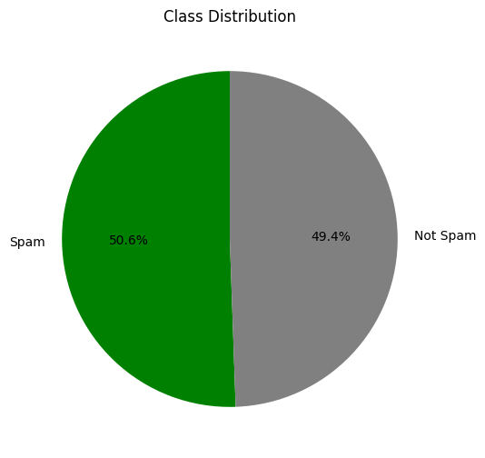

**Figure 4.1 - Spam Classification**

## TEST CASES AND RESULT

**Table 4.2 Test Cases**

|  |  |  |  |  |  |
| --- | --- | --- | --- | --- | --- |
| **TEST CASE NO** | **MODULE** | **TEST CASE SUMMARY** | **EXPECTED OUTCOME** | **ACTUAL OUTCOME** | **RESULT** |
| **TC-01** | User Interaction | User submits an empty URL in the spam detection route. | The form should not allow an empty URL and display error message "Please provide a YouTube URL". | The form prevents submission and displays the error message "Please provide a YouTube URL". | PASS |
| **TC-02** | User Interaction & YouTube URL Validation | User submits an invalid URL (not YouTube) in the spam detection route. | The application should display an error message "Invalid YouTube URL". | The application displays the error message "Invalid YouTube URL" | PASS |
| **TC-03** | User Interaction, YouTube URL Validation, Comment Retrieval & Spam Detection | User submits a valid YouTube URL with comments. | The application should process comments, predict spam probabilities, generate a PDF report with comments and predictions, and display the final page with download link. | The application successfully processes comments, generates the PDF report, and displays the final page with download link. | PASS |
| **TC-04** | PDF Download | User clicks the download link for the generated PDF report. | The application should send the "output.pdf" file as an attachment. | The user receives the "output.pdf" file as a download. | PASS |
| **TC-05** | Error Handling (404) | User tries to access a non-existent route. | The application should display the main page. | The application displays the main page. | PASS |

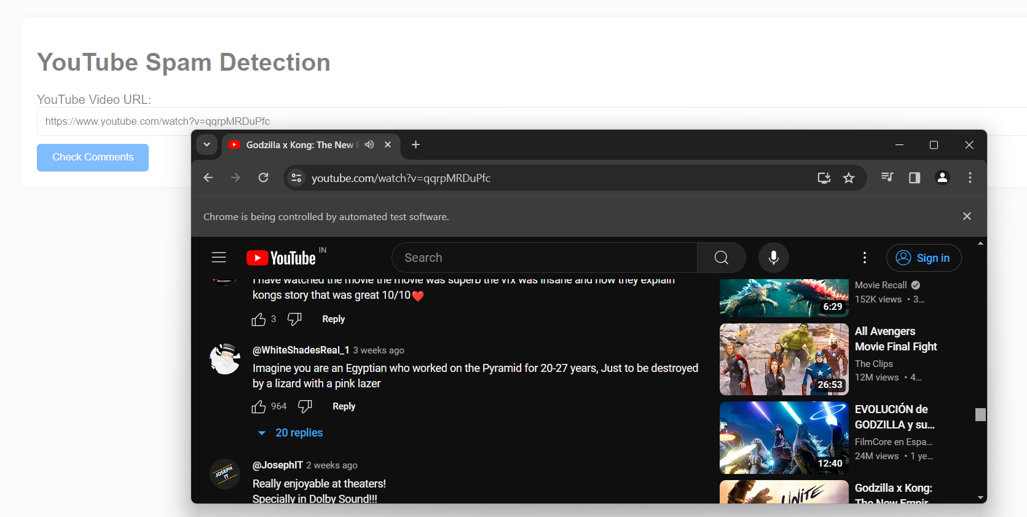

**Figure 4.2 - Comments Extraction**

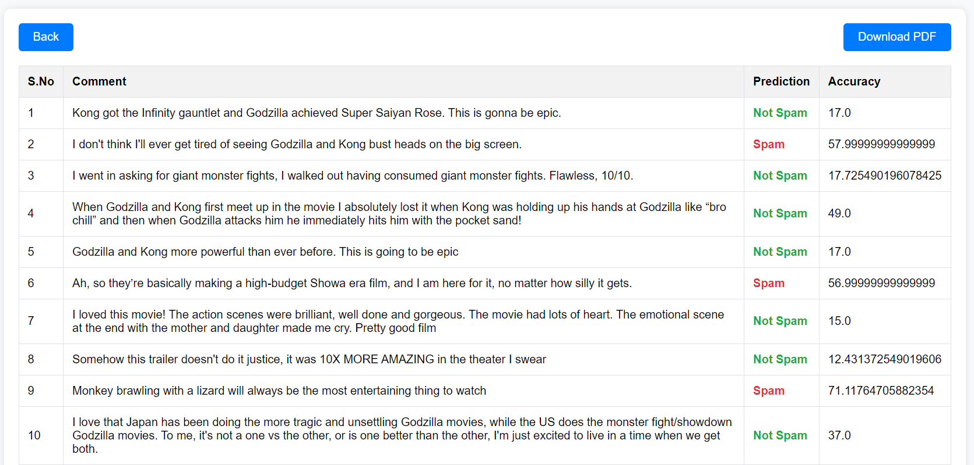

**Figure 4.3 - Comments Classification**

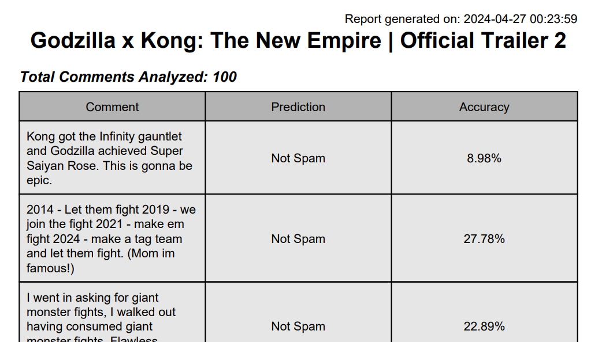

**Figure 4.4 - Report Generation**

## PERFORMANCE ANALYTICS

The Results obtained are analyzed and various assessment and carried out to determine the performance of the project. The Figure (4.5 – 4.9) table (4.2 – 4.6) summarizes the performance of the models based on precision, recall, and F1-score, along with the formulas used for each metric:

**Table 4.3 Formulas**

|  |  |  |
| --- | --- | --- |
| **Metric** | **Formula** | **Description** |
| **Precision (Class X)** | True Positives (Class X) / (True Positives (Class X) + False Positives) | Measures the proportion of comments identified as Class X that are actually Class X. |
| **Recall (Class X)** | True Positives (Class X) / (True Positives (Class X) + False Negatives) | Measures the proportion of actual Class X comments that are correctly identified. |
| **F1-Score (Class X)** | 2 * (Precision (Class X) * Recall (Class X)) / (Precision (Class X) + Recall (Class X)) | Harmonic mean of Precision and Recall for Class X, favouring models with a balance between both metrics. |
| **Accuracy** | (True Positives (Class 0) + True Positives (Class 1)) / Total Number of Samples | Proportion of total comments that were correctly classified. |
| **Macro Average** | (Average of Precision (Class 0), Precision (Class 1), Recall (Class 0), Recall (Class 1), F1-Score (Class 0), F1-Score (Class 1)) | Unweighted average of all metrics for each class. |
| **Weighted Average** | Weighted average of Precision, Recall, and F1-Score based on class distribution | Takes into account the class imbalance by weighting the metrics according to the number of samples in each class. |

**Table 4.4 Decision Tree Classification Report**

|  |  |  |  |
| --- | --- | --- | --- |
| **Metric** | **Class 0** | **Class 1** | **Overall** |
| Precision | 0.85 | 0.92 |  |
| Recall | 0.93 | 0.84 |  |
| F1-Score | 0.89 | 0.88 |  |
| Accuracy |  |  | 0.88 |
| Macro Average |  |  | 0.89 |
| Weighted Average |  |  | 0.88 |

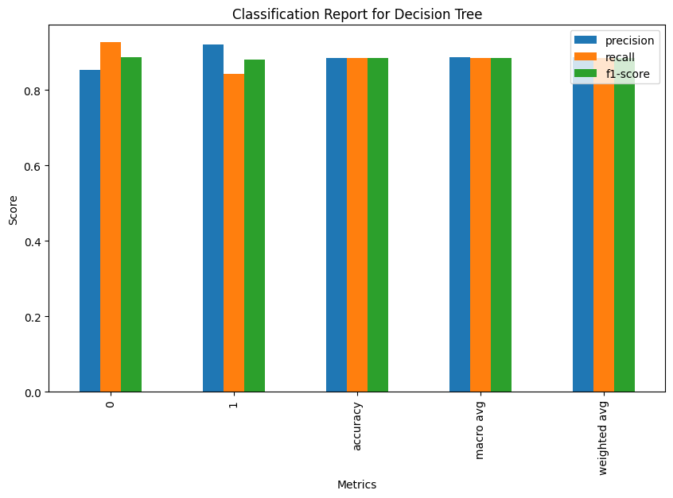

**Figure 4.5 - Classification Report for Decision Tree**

**Table 4.5 Logistic Regression Classification Report**

|  |  |  |  |
| --- | --- | --- | --- |
| **Metric** | **Class 0** | **Class 1** | **Overall** |
| Precision | 0.85 | 0.97 |  |
| Recall | 0.98 | 0.83 |  |
| F1-Score | 0.91 | 0.90 |  |
| Accuracy |  |  | 0.90 |
| Macro Average |  |  | 0.91 |
| Weighted Average |  |  | 0.90 |

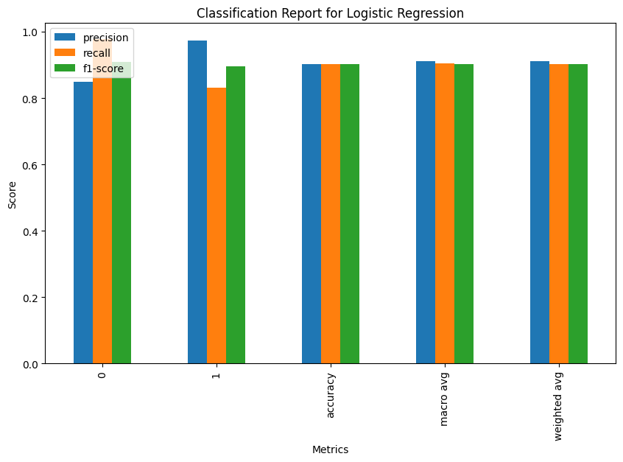

**Figure 4.6 - Classification Report for Logistic Regression**

**Table 4.6** **Random Forest Classification Report**

|  |  |  |  |
| --- | --- | --- | --- |
| **Metric** | **Class 0** | **Class 1** | **Overall** |
| Precision | 0.86 | 0.94 |  |
| Recall | 0.95 | 0.85 |  |
| F1-Score | 0.90 | 0.89 |  |
| Accuracy |  |  | 0.90 |
| Macro Average |  |  | 0.90 |
| Weighted Average |  |  | 0.90 |

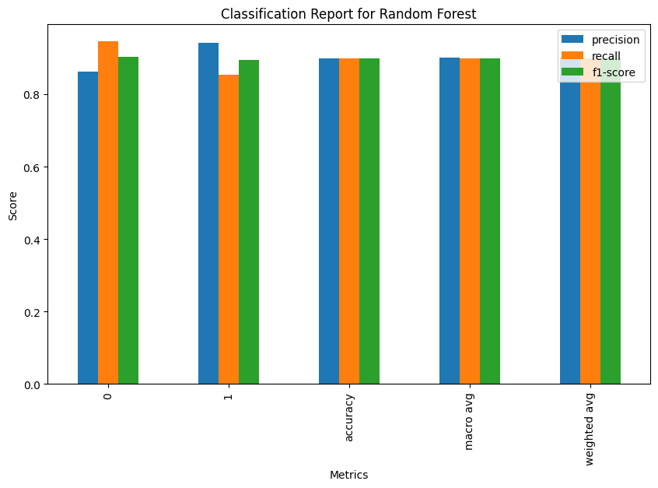

**Figure 4.7 - Classification Report of Random Forest**

**Table 4.7** **SVM Classification Report**

|  |  |  |  |
| --- | --- | --- | --- |
| **Metric** | **Class 0** | **Class 1** | **Overall** |
| Precision | 0.84 | 0.93 |  |
| Recall | 0.94 | 0.82 |  |
| F1-Score | 0.88 | 0.87 |  |
| Accuracy |  |  | 0.88 |
| Macro Average |  |  | 0.88 |
| Weighted Average |  |  | 0.88 |

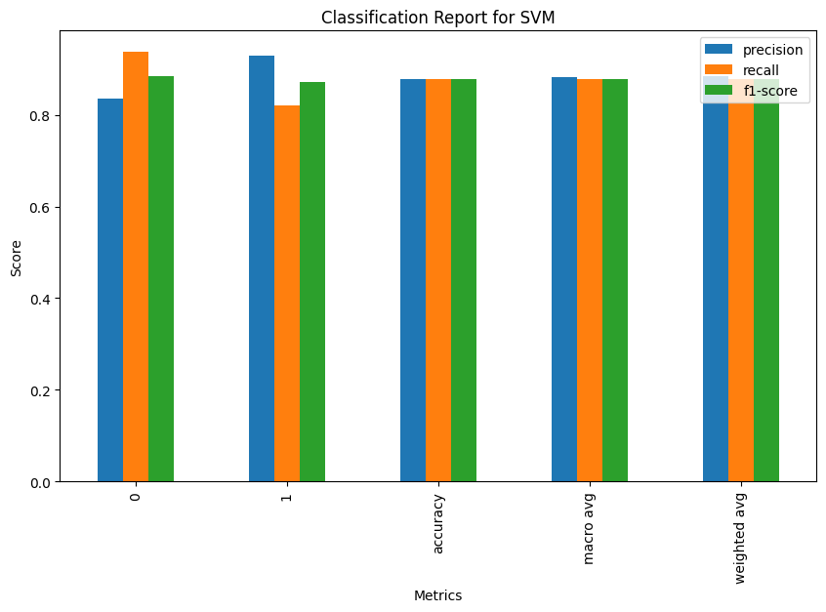

**Figure 4.8 - Classification Report for SVM**

**Table 4.8** **Extra Trees Classifier Report**

|  |  |  |  |
| --- | --- | --- | --- |
| **Metric** | **Class 0** | **Class 1** | **Overall** |
| Precision | 0.89 | 0.95 |  |
| Recall | 0.95 | 0.88 |  |
| F1-Score | 0.92 | 0.92 |  |
| Accuracy |  |  | 0.92 |
| Macro Average |  |  | 0.92 |
| Weighted Average |  |  | 0.92 |

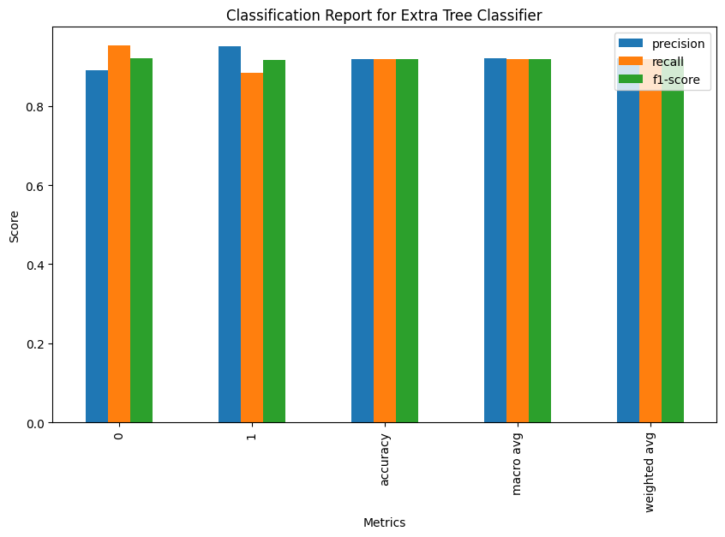

**Figure 4.9 - Classification Report for Extra Tree Classifier**

### EXPLANATION OF METRICS

* Precision: As show in figure 4.10, metric indicates the proportion of comments identified as spam that are actually spam. It reflects how good the model is at avoiding false positives (legitimate comments flagged as spam).
* Recall: This metric reflects how well the model identifies all the actual spam comments. It focuses on avoiding false negatives (spam comments missed by the model).
* F1-Score: This metric provides a balanced view by considering both precision and recall. It takes the harmonic mean of precision and recall, giving a higher score when both metrics are high.

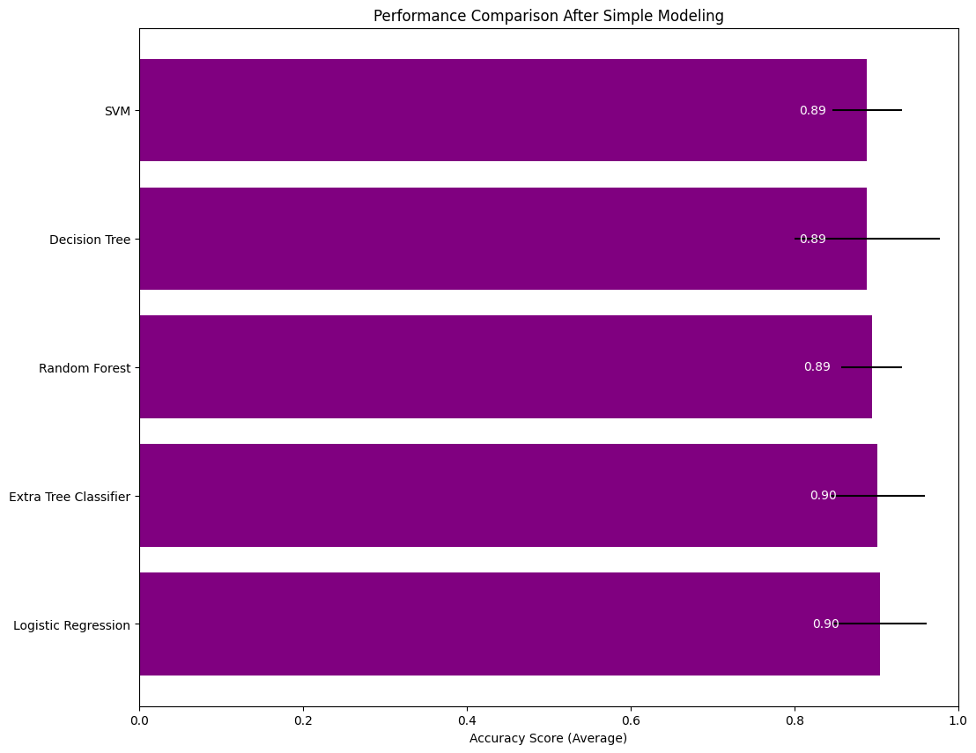

**Figure 4.10 - Performance Comparison After Simple Modeling**

### ANALYSIS

**Table 4.9** **Classification report for all the models**

|  |  |  |  |  |  |  |  |  |
| --- | --- | --- | --- | --- | --- | --- | --- | --- |
| **Model** | **Accuracy** | **Macro F1-score** | **Precision (Class 0)** | **Recall (Class 0)** | **F1-score (Class 0)** | **Precision (Class 1)** | **Recall (Class 1)** | **F1-score (Class 1)** |
| **Decision Tree** | 0.88 | 0.88 | 0.85 | 0.93 | 0.89 | 0.92 | 0.84 | 0.88 |
| **Logistic Regression** | 0.90 | 0.90 | 0.85 | 0.98 | 0.91 | 0.97 | 0.83 | 0.90 |
| **Random Forest** | 0.90 | 0.90 | 0.86 | 0.95 | 0.9 | 0.94 | 0.85 | 0.89 |
| **SVM** | 0.88 | 0.88 | 0.84 | 0.94 | 0.88 | 0.93 | 0.82 | 0.87 |
| **Extra Tree Classifier** | 0.92 | 0.92 | 0.89 | 0.95 | 0.92 | 0.95 | 0.88 | 0.92 |

The Given table represents that the highest accuracy (92%) was achieved by the Extra Tree Classifier, demonstrating balanced performance across both classes. Logistic Regression and Random Forest followed closely (90% accuracy). Decision Tree and SVM achieved a slightly lower accuracy (88%).

For imbalanced data, consider class-wise performance. Extra Tree Classifier maintained good precision and recall for both classes. Logistic Regression may favor the majority class.

Extra Tree Classifier is ideal for overall accuracy. For imbalanced data, select the model favoring the important class.

**CHAPTER 5**

# CONCLCUSION

## SUMMARY

In conclusion, YouTube comment spam disrupts user experience and hinders meaningful discussions. Automated comment classification offers a promising solution to tackle this challenge. It examined related studies on YouTube spam comment screening and conducted classification experiments with Five different ML techniques (Decision Tree, Logistic Regression, Random Forest, SVM, Extra Tree Classifier). By leveraging ML and meticulously curated datasets, comment classification systems can be trained to distinguish between legitimate comments and spam with high accuracy. A well-tuned model can significantly reduce spam while minimizing the misclassification of legitimate comments. This fosters a cleaner and more productive online environment for users to engage with video content and participate in constructive conversations.

## FUTURE WORK

While the proposed approach demonstrates promising results in tackling YouTube comment spam, there's always room for advancement. Here are some key areas for future exploration:

* Multilingual Detection: Expanding the model's capabilities to encompass a broader range of languages would significantly enhance its global impact. This would necessitate the incorporation of multilingual datasets and potentially exploring language-agnostic or transfer learning techniques.
* Advanced Contextual Understanding: By leveraging advancements in Natural Language Processing (NLP), the model could be further refined to grasp the nuances of human language. This includes effectively identifying sarcasm, humor, and cultural references within comments, leading to more accurate spam classification and mitigating the risk of misclassifying legitimate content.
* Explainable AI Integration: Implementing Explainable AI (XAI) techniques would provide valuable insights into the model's decision-making process. This would foster trust and transparency, allowing for targeted improvements and model refinement based on user feedback and evolving comment trends.
* User-Centric Feedback Mechanisms: Establishing user feedback loops would allow the model to continually learn and adapt. This could involve incorporating user reports or sentiment analysis of flagged comments, enabling the model to adjust its classification strategies over time based on real-world user preferences.

By steadily pursuing these future directions, researchers can develop even more robust and effective YouTube comment spam detection systems. This dedication to continuous improvement will ensure a cleaner and more enjoyable online experience for users worldwide, fostering a more productive and constructive environment for online video discussions.

# REFERENCES

1. H. Shaban. (Sep. 19, 2019). Nearly Half of Cellphone Calls Will be Scams by 2019, Report Says. The Washington Post. Accessed: Feb. 21, 2020.
2. O. Abayomi-Alli, S. Misra, A. Abayomi-Alli, and M. Odusami, ‘‘A review of soft techniques for SMS spam classification: Methods, approaches and applications,’’ Eng. Appl. Artif. Intell., vol. 86, pp. 197–212, Nov. 2019.
3. O. M. E. Ebadati and F. Ahmadzadeh, ‘‘Classification spam email with elimination of unsuitable features with hybrid of GA-naive Bayes,’’ J. Inf. Knowl. Manage., vol. 18, no. 1, Mar. 2019.
4. M. S. Hanif and M. Bilal, ‘‘Competitive residual neural network for image classification,’’ ICT Exp., vol. 6, no. 1, pp. 28–37, Mar. 2020.
5. H. Liu, M. Zhou, and Q. Liu, ‘‘An embedded feature selection method for imbalanced data classification,’’ IEEE/CAA J. Automatica Sinica, vol. 6, no. 3, pp. 703–715, May 2019.
6. Z. Lan, M. Chen, S. Goodman, K. Gimpel, P. Sharma, and R. Soricut, “Albert: A lite bert for self-supervised learning of language representations,” Feb. 2020.
7. S. Venkatraman, B. Surendiran, and P. A. R. Kumar, “Spam e-mail classification for the internet of things environment using semantic similarity approach,” J Supercomput, vol. 76, no. 2, pp. 756-776, 2020.
8. K. Sheridan. (2020). FBI: Business Email Compromise Cost Businesses 1.7B in 2019, Dark Reading. Accessed: Mar. 21, 2021.
9. Ali. (2020). Visualizing the Social Media Universe in 2020. Accessed: Jan. 14, 2021.
10. R. Lerman and H. Denham. (2020). 3 Charged in Massive Twitter Hack, Including Alleged Teenage ‘Mastermind’. The Washington Post. Accessed: Jan. 14, 2021.
11. Tingmin Wu, Shigang Liu, Jun Zhang, Yang Xiang (2021) Twitter Spam Detection Based on Deep Learning. The Australasian Computer Science Week Multiconference.